Joseph Ayo

Module 9.2 Assignment – CSD 325

Output using the given URL:  


Output after completing the tutorial directives and adding in formatting:  
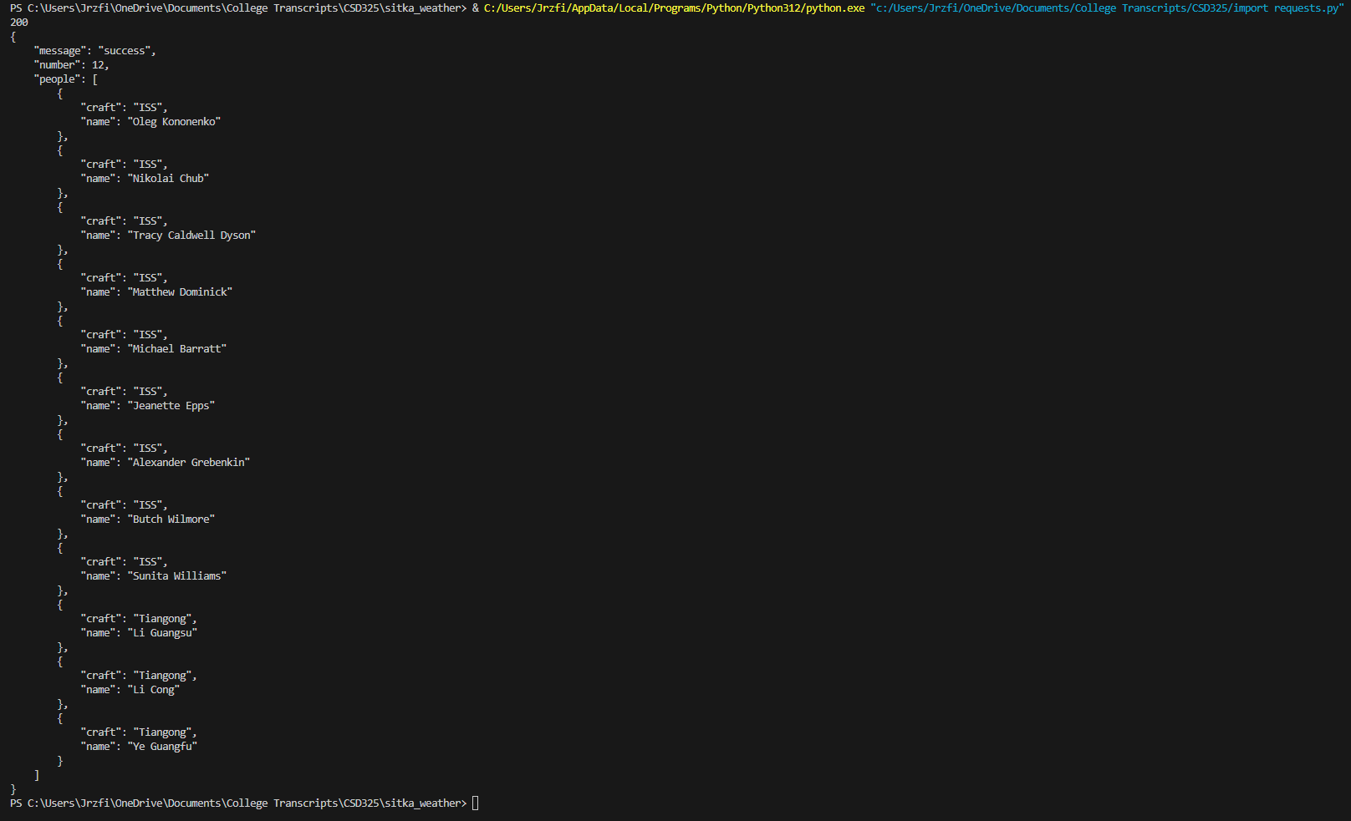

Output (unformatted) for an API that tracks the value of Bitcoin in various currencies:



Output (formatted):

